create table department(dno int primary key,dname varchar(30),hod varchar(20),loc varchar(20));

create table project(pno int primary key,pname varchar(20),sdate date,budget float,statuss varchar(20), check (statuss='c' || statuss='p'), dno int references department);

alter table department drop column loc;

INSERT INTO Department (dno, dname, HOD) VALUES

(1, 'HR', 'Mr. Desai'),

(2, 'IT', 'Ms. Smith'),

(3, 'Finance', 'Mr. Johnson');

INSERT INTO Project (pno, pname, sdate, budget, statuss, dno) VALUES

(101, 'Project A', '2024-06-15', 20000.00, 'P', 1),

(102, 'Project B', '2024-05-01', 15000.00, 'C', 2),

(103, 'Project C', '2024-07-01', 25000.00, 'p', 3),

(104, 'Project D', '2024-06-01', 12000.00, 'P', 1),

(105, 'Project E', '2024-04-15', 30000.00, 'C', 2),

(106, 'Project F', '2024-08-01', 5000.00, 'p', 4),

(107, 'Project G', '2024-09-01', 8000.00, 'c', 3);

select \* from project where sdate<'2024-06-15' and statuss='p';

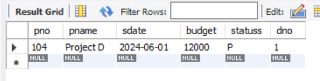

select pname,dname from project,department where department.dno=project.dno and statuss='p';



select sum(budget) from project,department where department.dno=project.dno group by dname;



select pname,dname from project,department where department.dno=project.dno and statuss='p' group by dname,pname;



select pname,hod from department,project where department.dno=project.dno and hod='mr. desai' group by hod,pname;



select hod,dname from department,project where department.dno=project.dno group by dname,hod;



select \* from project where project.pname like '%a' and budget>10000 order by budget desc;

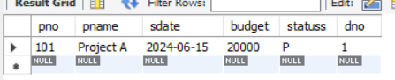

select \* from project where budget=(select max(budget) from project);

